A Definitive Guide to Generative AI with Amazon Bedrock

# Chapter 2: Generative AI with AWS

### 2.1 AWS Generative AI Stack

You can observe the rapid innovation in Generative AI happening in the industry. Even, enterprises want to adapt and accelerate to get benefits to solve their business use cases across industry. But enterprises are struggling to keep up with it. Most of the customer are conducting multiple experiments with various Generative AI provider, but integrating these solutions within their existing products is always challenging for them. Even, integrating into their operations is also challenging due to governance, security, and logistical concerns. Large enterprises often prefer providers like Amazon Web Services (AWS) due to reliability, maturity and familiarity. AWS is responding to this industry demand by continuously innovating in the Generating AI space by offering a simplified multi layered Generating AI stack consisting of infrastructure, tools for building Generating AI applications and pre-built Generative AI based applications. AWS emphasizes its commitment to providing purpose-built services, solutions and guardrails tailored to the specific needs of each user instead of one-size-fits-all approaches. This makes it the one platform that is being transformed into a global leader by innovation commitment and inclusivity combined with enterprise grade security and privacy.

This will come under three layers that make up the AWS Generative AI Stack. All these layers are equally important to accelerate Generative AI journey for customer based on the use cases they want to solve and user persona they want to address. AWS is investing all the three layer to help customer to accelerate their innovation.

1. Top layer of the stack: Application that leverage LLM’s and other FMs

2. Middle layer of the stack: Tools to build with LLM’s and other FMs

3. Bottom layer of the stack: Infrastructure for FM Training & Inferences

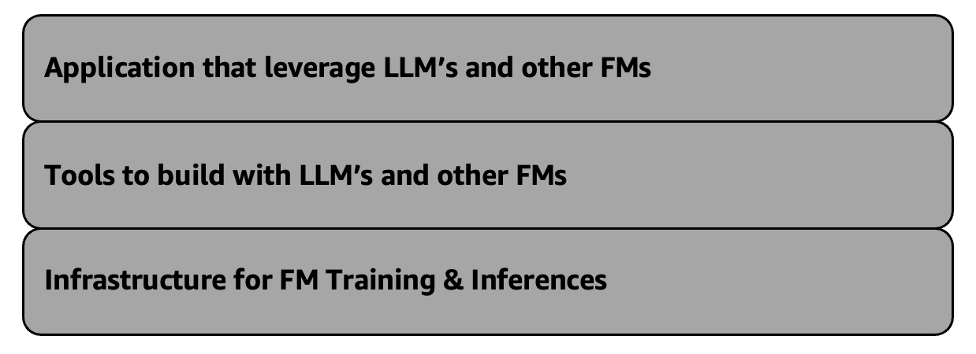

*Figure 2.1 – AWS Generative AI stack*

We will look at the bottom layer and upper layer in the below section. On the other hand, you will delve into the middle layer throughout the book.

*(* Refer AWS Generative AI Stack <https://aws.amazon.com/blogs/machine-learning/welcome-to-a-new-era-of-building-in-the-cloud-with-generative-ai-on-aws/> *)*

### **Bottom layer of the stack: Infrastructure for FM Training & Inferences**

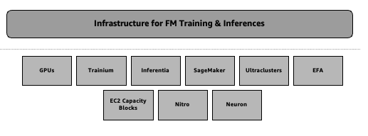

*Figure 2.2 – Bottom layer of the stack: Infrastructure for FM Training & Inferences*

Amazon Web Services (AWS) has remained as one of the forefront in terms of innovation in the domain of Machine Learning (ML) and Artificial Intelligence (AI) since the inception of Amazon. AWS continues to invest in ensuring that it offers the most advanced and accessible cloud-based infrastructure capable of supporting future large-scale AI models and applications providing specialized hardware to high-tech software tools.

The core of AWS’s ML ecosystem incorporates some essential innovations empowering clients to broaden their AI and ML initiatives beyond limits. These include potent GPU-powered cloud instances( virtual machines), purposed built silicon accelerated chip for ML inference and training, a fully managed service known as Amazon SageMaker for building, training and deploying any ML models, hyper scale GPU clusters as well as Elastic Fabric Adapter (EFA) which is a unique proprietary high performance networking technology. In addition, innovative consumption models such as EC2 Capacity Blocks have been introduced by AWS to ensure customers can get access to necessary GPU resources for their large scale ML projects based on their needs to get best price performances. The AWS Nitro System underlies all these advancements; it is a custom-built virtualization technology aimed at delivering industry leading performance along with cost-efficiency.

The Amazon Neuron SDK connects these hardware and software advances enabling the customers to enjoy the high performance capabilities of AWS’s built for ML Trainium and Inferentia chips without interruption. By simply incorporating Neuron in their existing pipelines, which support most Machine Learning models, customer can witness substantial enhancements in performance as well as reductions in expenses.

By means of such revolutionary changes, AWS provides its clients with an opportunity to solve such complicated issues related to AI and ML as training of large language models or deployment of high-speed inference at scale. As far as the ML space is concerned, AWS continues one of the leader in cloud based Machine Learning into the future by ensuring that customers are provided with cutting-edge infrastructure that is easily accessible for their ambitious AI and ML projects.

Now, take a look at every single part overview of the bottom layer.

### **Graphics processing unit (GPU)**

Customers across the globe are leveraging this collaboration between AWS and NVIDIA for their innovation journey and using these powerful Graphics processing unit (GPU) capabilities. These are the solutions that have been designed for companies to speed up their Machine Learning (ML), High Performance Computing (HPC), IoT services and even virtual workstations.

Some of the major advantages of making use of AWS Cloud for NVIDIA’s GPU-based cloud instances include:

**Rapid, Scalable ML Training:** Amazon EC2 instances powered by the latest NIVIDIA GPUs such as A100 Tensor Core GPUs in P4d instances give industry leading performance for training complex ML models. Consequently, there is rapid iteration and scaling-up of ML training workloads through high-throughput, low-latency networking capabilities.

**Affordable ML Inference Solutions**: G4 instances with NVIDIA T4 Tensor Core GPUs represent the most cost-effective GPU-powered cloud instances when it comes to ML inference. This means that enterprises can run ML models in production environments at an ideal price-performance ratio.

**Flexible, Versatile Virtual Workstations**: AWS-backed GPU-accelerated instances provide enough computational power to maintain strong remote virtual workstations. Therefore, such virtual workstations are available to designers, engineers, researchers and other professionals who require GPU-accelerated applications and cloud-based supercomputing power for their work.

**HPC Solutions Advance**: P3 is among instance families having many-GPUs with up to 8 NVIDIA V100 GPUs that are used in computationally intensive HPC workloads on the cloud which deliver mixed-precision performance at petaflop scale.

For over a decade now it has been NVIDIA’s long-term partnership with AWS that has made some of the most significant contributions to GPU-powered infrastructure starting from being the first to bring GPUs to the cloud over more than 13 years ago. This is why AWS became the first company to introduce GPUs into its cloud services over a decade ago and lately started offering NVIDIA H100 GPUs in P5 instances as well. ( Refer <https://aws.amazon.com/nvidia/>)

### **AWS Inferentia**

The AWS Inferentia chip is the purpose build silicon that has been created by AWS to further drive innovation in cloud based Machine Learning (ML) inference workloads. Some years ago, AWS realized that they needed to innovate at the silicon level so as to push boundaries of best price performance for ML inference workloads.

This investment has led to the development of a purpose built inference chip, the AWS Inferentia, which is designed for large scale ML deployments with high performance and cost efficiency. AWS has now launched the second generation Inferentia2( Inf2) chips powering the new Amazon EC2 Inf2 instances after the success of the first generation Inferentia chips.

The Inf2 instances provide significant advantages to customers who run Generative AI applications at scale with hundreds of billions of parameters:

**Cloud's Optimal Inference Cost**: Inf2 instances deliver the optimal cost per inference in the cloud, allowing organizations to deploy their ML models in production environments at optimal price points.

**Enhanced Performance, Reduced Latency**: The new Inf2 instances offer up to 4 times higher throughput and up to 10 times lower latency compared with previous generation Inf1 instances. This enables faster and more responsive inference without sacrificing performance.

**Ultra-Large Models Optimization**: Conversely, Inf2 instances can run inferences on ultra-large ML models much more efficiently by up to 12 Inferentia2 chips. The high-speed connectivity between the accelerators allows customers to distribute these massive models across multiple chips without compromising latency.

The introduction of AWS Inferentia and the latest Inf2 instances demonstrates AWS's continued drive to innovate at the silicon level and deliver the most cost-effective and high-performance inference capabilities in the cloud. ( Refer <https://aws.amazon.com/machine-learning/inferentia/> *)*

### **AWS Trainium**

To complement the advancements in inference capabilities with AWS Inferentia, the company has also developed its own purpose built chip for Machine Learning (ML) training workload the AWS Trainium.

The first-generation Trainium powered EC2 Trn1 instances are already delivering significant benefits for customers training large scale ML models. Compared to general-purpose GPU instances, the Trn1 instances optimized for distributed training have demonstrated impressive results:

**Model Training Acceleration**: For example, Ricoh managed to train multibillion parameters language models in a few days on their Trn1 instances. The combination of Trainium chips and the high-speed networking enables faster distributed training at scale. ( *Refer:* [*https://aws.amazon.com/machine-learning/trainium/customers/*](https://aws.amazon.com/machine-learning/trainium/customers/) )

**Price Performance Enhancement**: Databricks has reported up to significant better price-performance when training large deep learning models on Trainium based instances versus traditional GPU powered options. ( *Refer:* [*https://aws.amazon.com/machine-learning/trainium/customers/*](https://aws.amazon.com/machine-learning/trainium/customers/) )

AWS on its part is not resting on its laurels. The next generation Trainium2 chips and instances are already being launched by the company. In comparison to Trainium1, Trainium2 will power the highest performance compute on AWS to train foundation models more quickly, more affordably, and with less energy consumption.

Trainium2 chips are intended to offer up to four times the faster training when compared with Trainium of the first generation. When leveraged in the upcoming EC2 UltraClusters, Trainium2 will enable up to 65 exaflops of aggregate compute power.

AWS's continued innovation in custom silicon for ML, from Inferentia to Trainium and now Trainium2, demonstrates the company's commitment to providing the most powerful and cost effective training infrastructure in the cloud. These purpose-built solutions are empowering customers to push the boundaries of what is possible with large-scale, complex AI models. ( Refer <https://aws.amazon.com/machine-learning/trainium/>)

#### **Amazon SageMaker**

You will use extensively Amazon SageMaker Chapter 6 onwards to solve certain use cases development. However, let us first get the overview of Amazon SageMaker in this section.

Amazon Web Services (AWS) has been one of the leader in delivering Machine Learning (ML) in the cloud. They have constantly strived to make it easier and more accessible for businesses to build, train, and deploy sophisticated AI models. At the heart of this effort is Amazon SageMaker, the fully managed ML service.

Over the years, AWS has added more than 380 new features and capabilities to SageMaker, transforming it into a comprehensive end-to-end platform for the ML lifecycle. Some of the key advancements include:

**Streamlined Model Optimization Process**: SageMaker's built-in capabilities for automatic model tuning and hyperparameter optimization help data scientists rapidly find the optimal model configurations.

**Scalable Distributed Model Training**: The platform supports seamless distributed training, enabling customers to scale out the training of even the largest models across multiple servers.

**Versatile Deployment**: SageMaker provides a variety of options for deploying trained models, from fully managed hosting to container-based hosting and serverless inference.

**Integrated and Unified ML Ops**: SageMaker integrates tools for the full ML operations lifecycle, from data preparation to model monitoring and lineage tracking.

**Responsible AI**: The platform incorporates features to help customers build and deploy AI systems in a responsible and ethical manner.

**Continuing the Innovation Journey:** AWS is now making it even easier and more cost effective for customers to train and deploy large-scale models, including large language models (LLMs) and other foundation models (FMs).

Specifically, AWS has introduced two new capabilities within SageMaker:

**SageMaker Model Dashboard**: This centralized hub provides customers with visibility and control over all their models, making it simpler to manage the deployment and monitoring of large-scale models.

**SageMaker Inference Recommender**: This new service automatically analyzes a customer's model and workload requirements, and then recommends the optimal instance type and configuration for cost-effective and high-performance inference.

**SageMaker Jumpstart**: Amazon SageMaker JumpStart simplifies Machine Learning with its pre-trained open-source models that cover a variety of problem types. These models supports transfer learning and can be fine-tuned prior to deployment. There are solution templates for common use cases as well as executable notebooks for SageMaker. Through Jumpstart, you may deploy and evaluate popular hub models in Studio experience. The updated Studio and the classic studio experiences both have pre-trained models access, templates and examples. Foundation model is provided in the jumpstart for things like content writing, code generation and summarization so that users can create their generative AI solutions For example, Some of these pervasive trained models (e.g., LLaMa-2-7b or GPT-J 6B) serve as starting points towards purpose built models usable in massive text data sets and multilingual tasks alike. Detail product information is out of scope of this book. ( *Refer https://docs.aws.amazon.com/sagemaker/latest/dg/studio-jumpstart.html )*

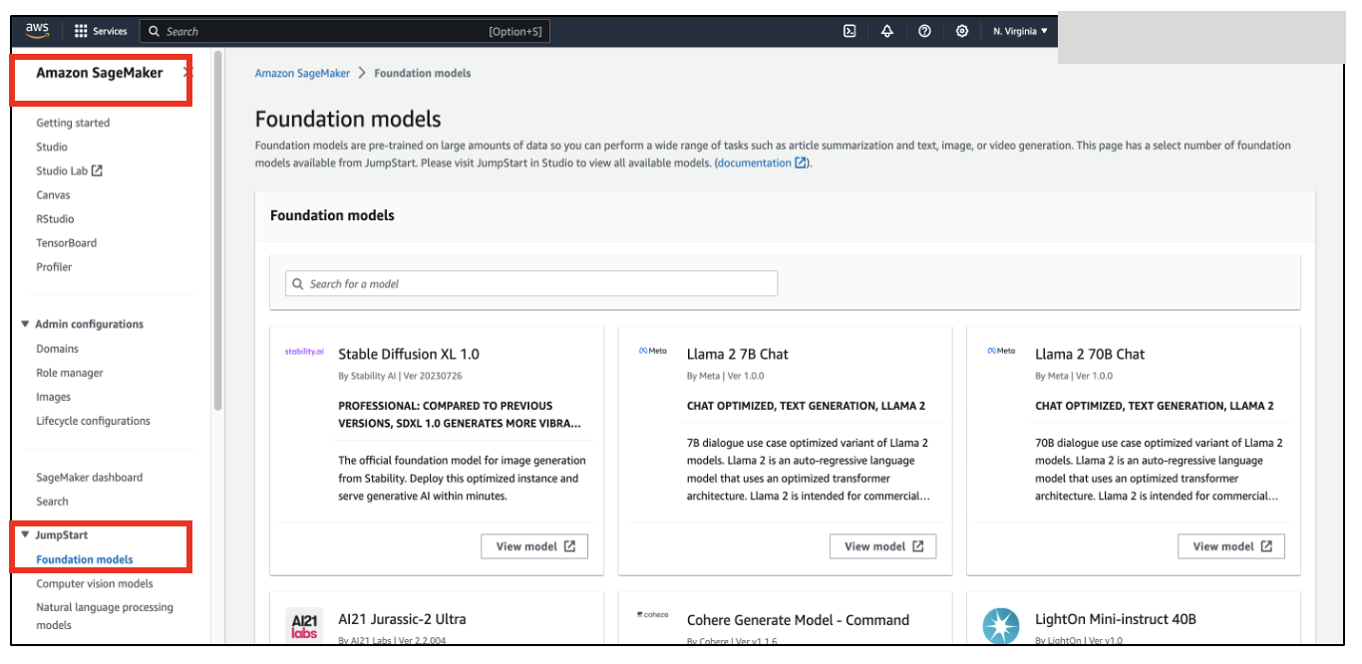

*Figure: 2.3 Amazon SageMaker Jumpstart at console*

Combined with a wide array of Amazon SageMaker features and tools, these latest innovations make it possible for organizations to quickly develop, train, and deploy sophisticated AI models including complex Foundation models at any scale possible.

As the ML landscape continues to evolve, AWS remains committed to driving innovation in SageMaker, ensuring customers have access to the most powerful and comprehensive platform for their AI and ML initiatives. ( Refer <https://aws.amazon.com/pm/sagemaker/>)

#### **UltraClusters**

Amazon Web Services (AWS) has invested heavily in providing customers with the most capable and scalable GPU infrastructure in the cloud as the need for large scale ML models grows. One important development here was the introduction of Amazon EC2 UltraClusters.

UltraClusters are hyper-scale GPU clusters that bring together thousands of accelerated instances co-located within a single Availability Zone and interconnected with a non-blocking network. This unique architecture enables unprecedented scale and performance for training even for the most complex and largest ML models.

In particular, these UltraClusters can provide an aggregate bandwidth of up to 3,200 Gbps which is needed to achieve massive parallelism for distributed training on models having hundreds of billions to trillions of parameters. When combined with the latest Trainium2 chips, the UltraClusters are expected to achieve up to 65 exaflops of aggregate compute power.

Customers derive various advantages from UltraClusters:

**Accelerated Model Training**: Customers can train their largest language models or other foundation models in a matter of few weeks, rather than few months, by leveraging the immense GPU resources and network bandwidth of UltraClusters.

**Enhanced Cost Efficiency**: The ability to distribute training workloads across thousands of GPU instances helps customers to achieve best price performance for their compute-intensive Machine Learning workloads.

**Demystify Resource Management**: UltraClusters abstract away the complexity of managing a large-scale and high-performance GPU cluster. Customers can focus on their core Machine Learning development.

Furthermore, to make it even easier for any customer to access the GPU capacity required for Generative AI and other ML workloads, AWS has introduced Amazon EC2 Capacity Blocks for ML. This is the only first consumption model in this sector enabling consumers to reserve GPUs for future use within EC2 UltraClusters. You will learn Amazon EC2 Capacity Blocks in next section.

The combination of UltraClusters and Capacity Blocks demonstrates AWS's commitment to delivering the most advanced, scalable, and accessible GPU infrastructure to power the next generation of large-scale AI models. ( *Refer* [*https://aws.amazon.com/ec2/ultraclusters/*](https://aws.amazon.com/ec2/ultraclusters/) )

#### **Elastic Fabric Adapter (EFA)**

Organization are expanding their landscape with large scale Machine Learning (ML) workloads and deal with massive volumes of data. Therefore, the demand for efficient and scalable inter-node communication has grown more urgent. AWS has introduced a proprietary networking technology known as the Elastic Fabric Adapter (EFA) in response to the industry needs.

EFA offers a robust network interface with low latency, high bandwidth and highly scalable communication for distributed computing. AWS empowers customers to maximize the potential of their ML workloads leveraging EFA. Users optimize their computing processes, achieving efficient and effective performance.

Customers derive various advantages from EFA:

**High Bandwidth Rapid Scaling**: EFA provides up to 100 Gbps of throughput per instance. It scales to a total aggregate bandwidth of 3,200 Gbps within a cluster. This substantial networking capacity guarantees that inter-node communication remains efficient, preventing any bottleneck, particularly for data-intensive tasks.

**Smooth and Effective Distributed Computing**: EFA can process data at a maximum rate of 100 Gbps per instance. It scales up to 3,200 Gbps of full aggregate bandwidth in a cluster. This has the advantage of preventing bottlenecks and enabling effective inter-node communication, particularly for data-intensive tasks.

**Enhanced Price Performance**: The high-performance capabilities of EFA allow data to flow inter node with ease. This optimization improves distributed computation of ML workload and other large-scale computations. Accelerated processing and increased productivity across all workloads benefit customers.

The EFA technology is a key enabler for AWS's Amazon EC2 UltraClusters, which bring together thousands of GPU instances interconnected with EFA for unprecedented scale and performance in training large language models and other foundation models.

Beyond just powering the UltraClusters, EFA is also available as a standalone networking option for other Amazon EC2 instances. Clients can take advantage of high-throughput, low-latency networking in a variety of distributed computing applications, such as large-scale data processing and scientific simulations. EFA has made it possible to handle a range of tasks efficiently and with optimum pricing.

AWS is dedicated to delivering modern infrastructures for contemporary high-performance computing that is large-scale through the use of EFA. This drive towards innovation enables customers employ advanced technology to meet their computational requirements satisfactorily. ( *Refer* [*https://aws.amazon.com/hpc/efa/*](https://aws.amazon.com/hpc/efa/) )

#### **Amazon EC2 Capacity Block**

EC2 Capacity Blocks are the first and only consumption model in the industry that allows customers to reserve GPU compute capacity in advance, guaranteeing the availability of the required resources when they need them for their short-duration ML training jobs.

By introducing EC2 Capacity Blocks, AWS has established itself as the top cloud provider for firms that aim to leverage the power of large language models and other foundational models. Besides its Trainium and Inferentia custom silicon investments, this solution shows AWS dedication to supplying highly developed and open infrastructure for Machine Learning's future. ( *Refer* [*https://aws.amazon.com/ec2/capacityblocks/*](https://aws.amazon.com/ec2/capacityblocks/))

#### **AWS Nitro**

The core technology underlying the upcoming generation of Amazon Elastic Compute Cloud (Amazon EC2) instances is the AWS Nitro System. This proprietary virtualization technology has allowed AWS to lower customer costs, innovate more quickly, offer new instance types and enhanced security.

Traditionally, hypervisors were used in virtualization to perform a variety of tasks. The Nitro System employs an alternative strategy, where AWS is able to deliver nearly all of a server's resources directly to the EC2 instances by dividing these tasks up and assigning them to specialized hardware and software, resulting in significant cost savings.

Architectural innovation particularly beneficial for Generative AI workloads, require immense computing power. Nitro System enables AWS offer accelerated computing instances up to 3,200 Gbps Elastic Fabric Adapter (EFA) networking, exascale-level computing power through Amazon EC2 UltraClusters. Capabilities, combined with Nitro System's efficient virtualization, make AWS's infrastructure most performant for generative AI applications. ( *Refer* [*https://aws.amazon.com/ec2/nitro/*](https://aws.amazon.com/ec2/nitro/))

#### **AWS Neuron**

Demand powerful efficient Machine Learning (ML) solutions, Amazon made significant investments developing specialized hardware software help customers unlock full potential ML workloads. Key component Amazon's ML ecosystem Amazon Neuron, software development kit (SDK) enables customers maximum performance AWS's purpose-built ML chips, Trainium and Inferentia. Since introducing Neuron 2019, AWS made substantial improvements underlying compiler framework technologies. Neuron supports wide range popular ML models, including large language models Llama 2 from Meta, MPT from Databricks, Stable Diffusion from Stability AI. Neuron compatible 93 top 100 models Hugging Face model repository, ensure customers easily integrate Neuron existing ML pipelines built on frameworks like PyTorch and TensorFlow, support JAX expected early 2024. ( *Refer* [*https://aws.amazon.com/machine-learning/neuron/*](https://aws.amazon.com/machine-learning/neuron/))

### **Middle layer of the stack: Tools to build with LLM’s and other FMs**

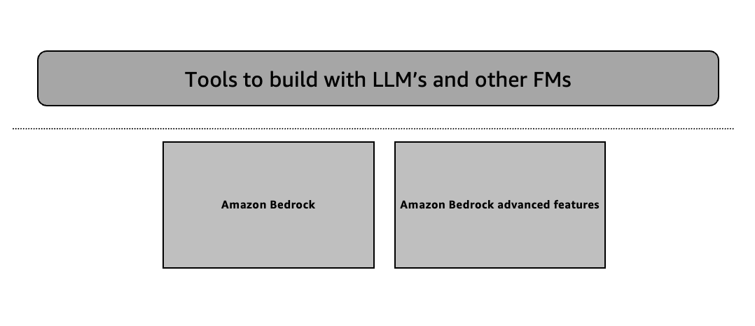

### *Figure 2.4 – Middle layer of the stack: Tools to build with LLM’s and other FMs*

However, you will drive deep into the details of this layer in the subsequent remaining chapters. But, the middle layer of the AI stack offers large language models (LLMs) and other foundation models (FMs) as a service on Amazon Bedrock. Amazon Bedrock allows customers to choose from industry leading models, customize them with their own data( domain adaption), and leverage AWS features like cloud best security, access controls and best practises. Customers across various industries are using Amazon Bedrock for diverse Generative AI applications like including chatbots, investment analysis, energy analytics, and website creation etc. You will learn some of the solutions in the subsequent remaining chapters along with some advanced features of Amazon Bedrock.

**Expanding Model Choice**: Amazon Bedrock is hosting new models like Anthropic Claude 2.1, Meta Llama 2 70B, Mistral, Cohere, Stability AI's Stable Diffusion XL 1.0 and many more. Amazon's own Titan models (Titan Text Lite and Titan Text Express) are also available for optimized accuracy, performance, and cost. New models include Titan Multimodal Embeddings for multimodal search and Titan Image Generator for text-to-image generation. You will learn depth and breadth of all the available model in the next chapter.

**Customization Capabilities**: Fine-tuning allows customers to privately train models on their own data for more relevant and accurate responses. Retrieval Augmented Generation (RAG) enables models to access and incorporate data from customers' proprietary sources. Continued pre-training allows models to learn domain-specific language and terminology. You will learn all these advanced techniques like pre-training (chapter 10), fine-tunning (chapter 10), and RAG architecture (chapter 6) design patterns in the subsequent chapters.

**Agents for Multistep Tasks**: Agents can plan and execute multistep complex tasks across enterprise systems and data sources quickly with low development efforts. Developers can easily build and execute Agents and integrate with AWS Lambda and other features of Amazon Bedrock without deep expertise. You will learn Agents on Amazon Bedrock in chapter 9.

**Responsible AI Guardrails**: Guardrails allow customers to apply customised safeguards based on their use case requirements, industry and responsible AI policies. Upcoming features include PII redaction and expanded content filtering. You will learn Guardrails on Amazon Bedrock in chapter 8.

Overall, Amazon Bedrock aims to provide customers with a flexible, secure, and customizable platform to accelerated build and scale their Generative AI applications.

### **Top layer of the stack: Application that leverage LLM’s and other FMs**

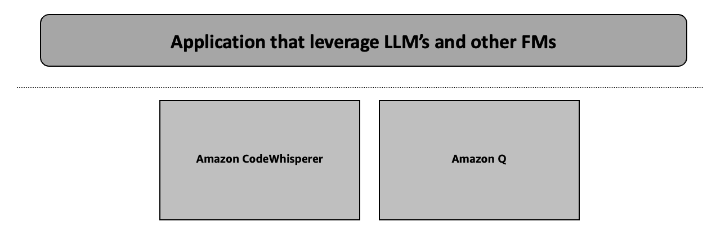

### *Figure 2.5 – Top layer of the stack: Application that leverage LLM’s and other FMs*

This layer talks about couple of AI assistance applications leveraging Generative AI. This layer bringing great value like accelerating software engineering covering variety of use cases within software engineering life cycle. You will learn overview of Amazon CodeWhisperer and Amazon Q below. Detail product information is out of scope of this book.

### **Amazon CodeWhisperer**

Amazon CodeWhisperer is an AI code completion tool leveraging Generative AI model developed by AWS. It helps developers to write more efficiently and effectively code.

The following are some of Amazon CodeWhisperer's main advantages:

**Rapid Coding**: Amazon CodeWhisperer produces intelligent code recommendation to speed up writing of code. It examines the context of your code using a generative AI model.

**Better Code Quality**: Amazon CodeWhisperer assists developers in writing cleaner, more maintainable code and lowers the risk of errors and bugs by offering pertinent and accurate code snippets.

**Increased Productivity**: Amazon CodeWhisperer helps developers spend more time on high-value development work and less time looking for answers by automating tedious coding tasks and offering contextual help.

**Language Support**: Python, Java, JavaScript, TypeScript, and many more programming languages are supported by Amazon CodeWhisperer. It helps developers working with a variety of technologies.

**Seamless Integration**: it integrates directly with well-known Integrated Development Environments (IDEs) like Visual Studio Code. You can access Amazon CodeWhisperer's features without interfering with your current development workflow.

**Personalized Suggestions**: Amazon CodeWhisperer learns from your coding style and preferences and provides personalized code suggestions that are tailored to your individual needs and patterns.

**Security and Privacy**: Amazon CodeWhisperer is designed with best security and privacy in mind and ensures that your code and data remain protected.

Overall, Amazon CodeWhisperer aims to enhance developer productivity, improve code quality, and streamline the software development process by leveraging the power of AI and machine learning. (*Refer* [*https://aws.amazon.com/codewhisperer/*](https://aws.amazon.com/codewhisperer/) *)*

### **Amazon Q**

Amazon Q is a conversational AI assistant developed by AWS that is designed to help users with a wide range of tasks and queries.

The following are some of Amazon Q's main advantages:

**Versatile Assistance**: Amazon Q can assist users with a variety of tasks like general information lookup and research to scheduling, task management, and even coding support.

**Natural Language Interaction**: Amazon Q makes use of natural language processing (NLP) technology so as to comprehend and respond to user queries in a conversational, intuitive way that makes it easy for users to interact with the assistant.

**Personalized Experiences**: In Amazon Q, personalized recommendations, suggestions and it tailors the experience for each individual user’s needs and habits based on their interactions.

**Continuous Learning**: Q Amazon keeps on evolving and improving itself thereby making it more precise and assisting with time. However, it does not use the company’s information to enhance the service thereby maintaining the privacy of customer’ data.

**Multimodal Interactions**: It is possible for users to talk to Amazon Q using text, voice or even visual inputs which makes its user experience seamless and comprehensive in nature.

**Scalable and Secure**: Basically, Amazon Q has built this function on a scalable infrastructure that is also secure hence giving confident help for customers.

**Integration Capabilities**: With other AWS services as well as third-party applications that integrates with Amazon Q, one an access a variety of features as well as data sources via single interface.

**Collaboration and Productivity**: Amazon Q can assist users with collaborative tasks like scheduling meetings, sharing information, and coordinating workflows. It enhances overall productivity.

Overall, Amazon Q helps to be a versatile and intelligent assistant that can simplify and streamline a wide range of user tasks and queries. Amazon Q is in preview mode as of April, 2024. Ultimately, this enhances productivity and offerings to users. (*Refer* [*https://aws.amazon.com/q/*](https://aws.amazon.com/q/) )

### 2.2 Generative AI potential industry Use cases

You explored the AWS Generative AI stack capabilities in the previous section. It is important to understand the profound impact this technology can have across a wide range of industries and use cases.

While the previous section explored the AWS Generative AI stack capabilities that enable Generative AI, it's important to understand the profound impact this technology can have across a wide range of industries and use cases. The technological advancements of Generative AI represent a fundamental shift of solving business problems and create new ideas.

The industry is observing transformation of Generative AI applications to boost productivity, enhance customer experiences, accelerate innovation and unlock new business opportunities as organizations begin to harness the power of these models. The potential of Generative AI spans from automating repetitive tasks to generating novel content, analyzing complex data, and even assisting with mission-critical decision making.

In the next chapter, you will examine some of the most interesting and significant use cases for generative AI in important industries. These models are being used by organizations to explore the particular issues and concerns that each domain presents, to drive observable business outcomes, and to showcase the innovators who are redefining what is possible.

You will start to grasp just how transformative this technology can be when you delve into the myriad possibilities of Generative AI and explore its vast potential. Even, you will find yourself brimming with fresh insights and strategic visions on how Generative AI can revolutionize various aspects of business to stay ahead in the game and enhance experiences for all involved parties through the real-world case studies and examples shared in this book. Additionally, you will learn creative applications of Generative AI that help you obtain a competitive advantage and build closer relationships with business and customers.

Let's dive in and uncover the transformative power of Generative AI in action.

As per recent study from Mckinsey & Company, Let's dive in Generative AI use cases will have different impacts on business functions across industries.

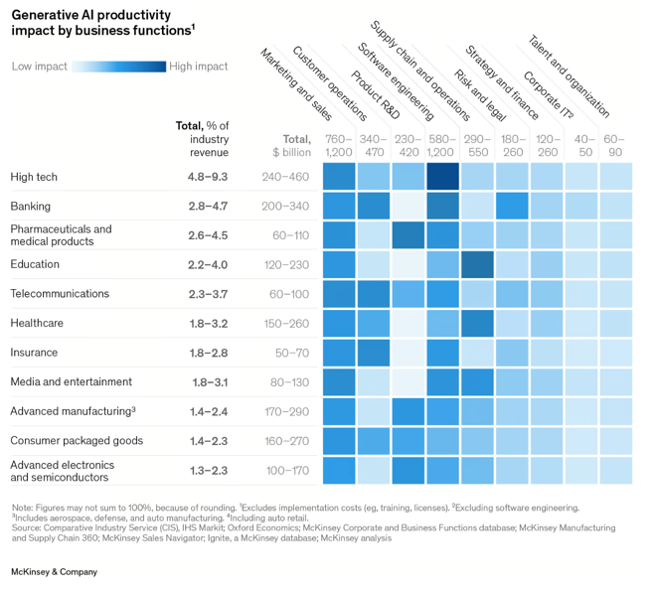

### *Figure 2.6 – https://www.mckinsey.com/capabilities/mckinsey-digital/our-insights/the-economic-potential-of-generative-ai-the-next-productivity-frontier#industry-impacts*

Generative AI has the potential to generate value between $2.6 trillion and $4.4 trillion across a variety of industries. The specific magnitude of its impact will hinge on a multitude of factors, including the composition and significance of diverse functions, along with the scale of revenue within each industry like High tech, Banking, Life sciences, Telecommunications, Healthcare, Insurance etc. (Figure 2.5)

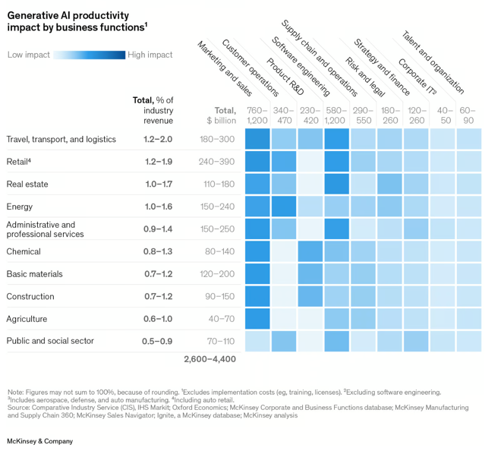

### *Figure 2.7 – https://www.mckinsey.com/capabilities/mckinsey-digital/our-insights/the-economic-potential-of-generative-ai-the-next-productivity-frontier#industry-impacts*

Even, there are numerous pertinent use cases in the retail, energy, public, and social sectors, as well as travel, transportation, and logistics. (Figure 2.6)

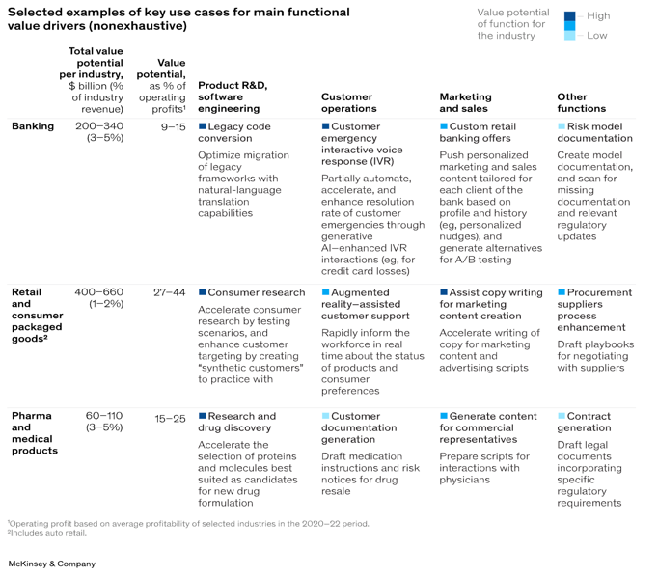

### *Figure 2.8 – https://www.mckinsey.com/capabilities/mckinsey-digital/our-insights/the-economic-potential-of-generative-ai-the-next-productivity-frontier#industry-impacts*

McKinsey's analysis suggests that Generative AI could add approximately $310 billion in added value to the retail industry (including auto dealerships) by enhancing performance in areas like marketing and customer interactions. Conversely, the primary source of potential value in the high-tech sector stems from Generative AI's capability to expedite and streamline software development processes.

Generative AI also has the potential to improve the efficiencies that Artificial Intelligence has already achieved in the banking industry by taking on low-value risk management tasks like in the area of reporting, regulatory monitoring, and data collection. Generative AI also has the potential to significantly advance drug discovery and development efforts in the life sciences sector. (Figure 2.7)

### 2.3 Why Generative AI on AWS

There are several reasons why businesses are thinking about partnering AWS for Generative AI. Here are a few of the most important points to talk about.

**Elasticity**: AWS offers elastic resources that automatically adjust to varying workloads. For example, a media company using AWS for Generative AI can effortlessly handle spikes in demand during peak viewing hours without manual intervention, ensuring seamless user experiences.

**Scalability**: AWS provides scalable infrastructure. It allows businesses to expand their Generative AI projects as needed. For example, an AWS-based e-commerce platform can effortlessly expand the image generation capabilities of its Generative AI application to meet the needs of an expanding user base without sacrificing efficiency.

**Cost Efficiency**: Pay-as-you-go pricing from AWS allows businesses to cut expenses by only paying for the resources they really use. For example, a startup experimenting with Generative AI on AWS can keep costs low during development and scale resources as the project matures and gains traction.

**Reliability and Availability**: The vast global data center network of AWS ensures excellent availability and dependability. For example, consider a healthcare company using AWS to develop generative AI applications. In the event of unforeseen disruptions, customers can rely on redundant infrastructure to maintain critical services and data availability.

**Monitoring and Observability**: For efficient troubleshooting and performance tracking, AWS provides comprehensive monitoring and observability tools. For example, A gaming company might integrate with apps based on generative AI and AWS CloudWatch. AWS CloudWatch tracks GPU and memory utilization.

**Global Reach**: AWS's global footprint enables organizations to deploy Generative AI projects closer to their target audiences. For example, a content distribution platform can leverage AWS's edge locations to deliver personalized video recommendations generated by Generative AI. Users can view worldwide with minimal latency.

**Managed Services**: AWS provides managed services that offload administrative tasks, allowing organizations to focus on innovation. For example, a financial institution adopting AWS for Generative AI can leverage Amazon SageMaker to streamline model training and deployment workflows, reducing time-to-market for new AI-powered services.

**Increased Flexibility and Choice**: AWS offers a wide range of services and tools for building and deploying Generative AI solutions. For example, a design agency can choose from various foundation model on Amazon Bedrock to enhance creative workflows and deliver compelling visual content to customer.

**Enterprise-Grade Security and Governance Capabilities**: AWS prioritizes security and compliance, providing robust security features and governance controls. For example, a government agency utilizing AWS for Generative AI can ensure data privacy and regulatory compliance by implementing encryption and access controls using AWS Identity and Access Management (IAM).

**State-of-the-Art Generative AI Capabilities**: AWS continuously innovates in the field of Generative AI, offering access to cutting-edge technologies and algorithms. For example, a research institution can leverage AWS's support for TensorFlow and PyTorch frameworks to experiment with advanced generative models like GANs and VAEs.

**Low Operational Overhead**: AWS minimizes operational overhead by managing infrastructure and services, allowing organizations to focus on core business objectives. For example, a manufacturing company exploring AWS for Generative AI can reduce IT maintenance costs and complexity, enabling engineers to focus on product design and innovation.

**Strong History of Continuous Innovation**: AWS has a proven track record of innovation, regularly introducing new features and services to meet evolving customer needs. For example, a retail company adopting AWS for Generative AI can leverage AWS's continuous innovation to stay ahead of competitors and deliver personalized shopping experiences powered by AI-driven recommendations.

Overall, leveraging AWS for Generative AI projects offers numerous advantages, including scalability, cost efficiency, reliability, global reach, managed services, security, flexibility, access to state-of-the-art technologies, low operational overhead, and a history of continuous innovation, making it a compelling choice for organizations seeking to unlock the full potential of AI.

### 2.4 Accelerate Generative AI Applications building on AWS

# AWS enables organizations to accelerate their Generative AI initiatives by providing a comprehensive suite of cloud services. The vision of AWS is to make more democratize and demystifying products, services, solutions help customer to accelerate building of Generative AI based applications. You will experience chapter 4 onwards. Some of the tools and technologies will help you to build six Generative AI based applications.

# Amazon Bedrock primarily will drive this discussion. You will learn most of the Amazon Bedrock features in the subsequent chapter. Whereas, managed Jupiter notebook is a great tool to build and explore Generative AI applications on Amazon SageMaker. Even, Amazon cloud9 native cloud-based IDE helps customer to build Generative AI based applications. Additionally, Amazon CloudWatch and Cloudtail provides comprehensive monitoring and observability capabilities.

# Organizations needs close attention to data ingestion, data engineering, data management, data governance, and capabilities for purpose-built data storage. So, Developing Generative AI applications requires a comprehensive data foundation strategy. This is one of the top priorities for businesses. A smooth native integration with Data & Analytics products is enabled to guarantee seamless interoperability and platform synergy.

# Organizations in a variety of industries can use AWS to leverage new heights of innovation, productivity, and competitive advantage in their Generative AI applications.

### 2.5 Generative AI Project Life Cycle

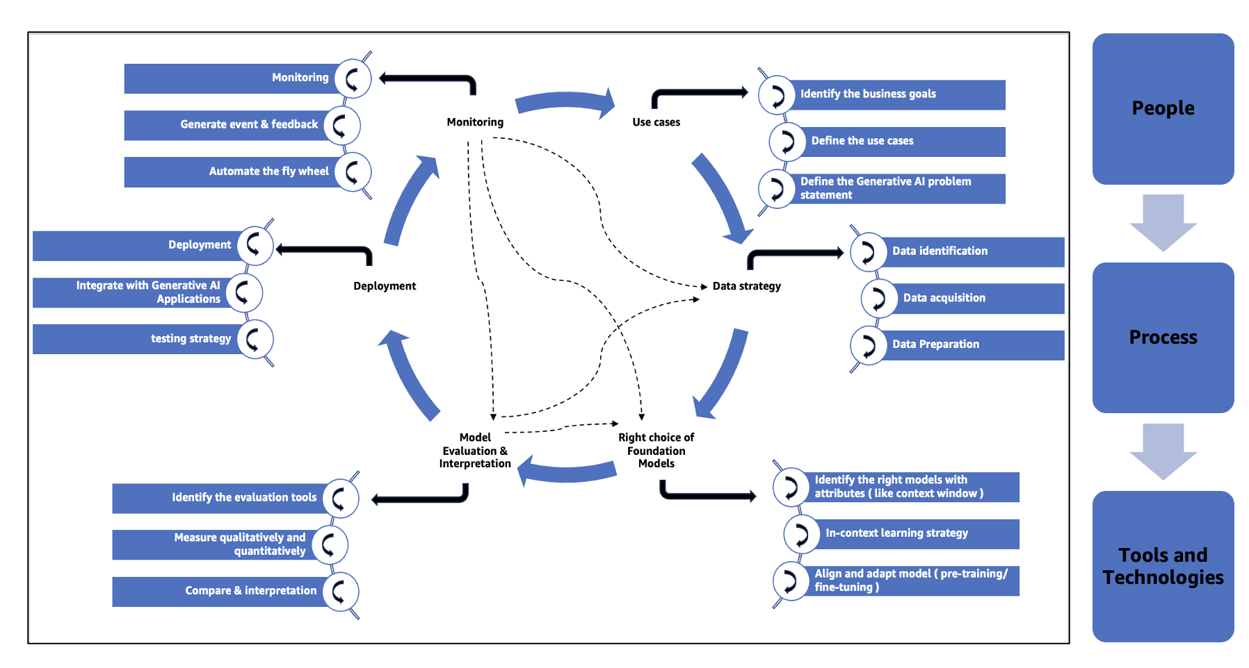

### *Figure 2.9 – Generative AI project lifecycle*

# People, processes and tools are important elements in the Generative AI project lifecycle for several reasons:

# **People**: Generative AI is a new technology in the industry for most of the resources. The importance of having a right strategy by Organizations to upskill resources using Generative AI, Cloud knowledge and AI-ML knowledge. Organizations need to focus on the right capability building in technology as well as business to build intuitive applications for solving real world business problem. Technology is moving too fast. For that reason, every organization should have a continuous learning and development program in this field.

# **Process**: Clear processes and workflows are essential for streamlining the lifecycles of Generative AI projects. This also ensures it becomes more effective, has uniformity as well as repeatability across different projects. These include managing use cases, building a strong data foundation, choosing appropriate Foundation Models, developing model evaluation and interpretation plans, making decisions on application deployment and establishing monitoring frameworks. Additionally, when there are clearly defined processes members of the team work together and communicate better which minimize errors and accelerate development cycles.

# **Tools and Technologies**: Differing stages of the generative AI project require appropriate tools and technologies. This mainly consists of databases and data lakes as ways of storing information, but also frameworks and libraries for Generative AI applications development and deployment. Furthermore, to maintain reproducibility and scalability while managing the complexity of Generative AI projects, tools for version control, experimentation tracking, model deployment, and monitoring are helpful.

# By integrating people, processes, and tools effectively, organizations can navigate the Generative AI lifecycle efficiently, from ideation to production deployment, and continuously improve the performance and reliability of Generative AI based applications.

# Another important lens to demystify the Generative AI project lifecycle on the below perspectives.

# **Use cases**: Defining use cases plays an important role in the initial success of Generative AI based projects. Businesses can verify the true worth of the generative AI solution. The use of cases for business understanding link well with the project goals to align with the overall strategy. It helps you set priorities and concentrate on main business objectives. Which makes it clear to achieve the desired outcome in business.

# Additionally, Well-specified cases help in understanding target persona, problem domain and specific requirements for the Generative AI solution. It describes specific scenarios or applications where to leverage Generative AI, including the end-user, the desired outcome, and the required functionality.

# You can identify the key elements of the problem, such as the input data, the desired output, the constraints, and the performance requirements by analyzing the use cases. Occasionally the problem statement clearly indicates whether model needs fine-tuning, pre-training or other mechanisms such as RAG or in-context learning.

# **Data strategy**: A strong data strategy ensures that Generative AI models train on high quality, relevant data. It enhances the performance and accuracy. Key data sources, types and formats that are important for project objectives can be identified by organizations.

# Crucially, a data strategy shows how to effectively and safely buy required information in a way that complies with regulations and protects privacy. It is very significant because it helps identify masses of elaborate datasets needed for building strong Generative AI model.

# Generative AI models require effective data management. This includes careful preparation steps to ensure output quality and maximize learning efficiency. A well-designed strategy enhances consistency, scalability, as well as making the reliability of model outcomes more effective by specifying duties such as data cleaning, normalization and feature engineering.

# **Right choice of Foundation Models**: Choosing the appropriate foundation model is essential for Generative AI projects. It affects the model's comprehension and production of contextually relevant outputs, including context window size.

# Equipped with the optimal foundation model tailored to the task, the AI system excels in capturing contextual details and producing high-quality outputs for diverse applications such as text generation and image captioning.

# The right choice of foundation models is crucial because it directly influences the Generative AI solution's ability to quickly adapt to new tasks or domains through in-context learning. Certain foundation models excel in this capability, enabling streamlined project lifecycles by minimizing the time and resources needed for model adaptation and deployment.

# **Model Evaluation & Interpretation**: Model Evaluation and Interpretation is important as it ensures that Generative AI models undergo rigorous assessment using appropriate qualitative and quantitative measures, aligning with project objectives to offer meaningful insights into model performance and interpretability. Businesses can make informed decisions, mitigate risks, and enhance the effectiveness of their Generative AI applications by selecting the right evaluation tools,

# Furthermore, Model Evaluation and Interpretation is vital because it facilitates comparison to benchmarks and other models, aiding in identifying areas for improvement and making informed decisions about deployment. It also lends a hand in evaluating the model’s suitability for use cases, unearths possible biases and informs adjustments to be made while refining the model in the course of the project lifecycle.

# **Deployment**: The right deployment strategy is paramount since it helps make Generative AI models accessible to end-users or other applications. Integration Generative AI with other applications and models is important if the model is to be part of big systems. Also, during deployment, a model should have a comprehensive testing strategy that guarantees that its functional, performance and quality standards are met while also minimizing risks in operation. At this point, the model undergoes extensive testing which will increase its reliability as well as user experience by detecting and fixing issues ahead of time before it is taken live.

# **Monitoring**: For generative AI solutions to operate effectively and consistently they must have robust monitoring and observability in place. This calls for early warning signs to be on the look-out for so that any weirdness happening within production may be promptly detected and appropriate action taken. Real-time events plus feedback loops stemming from anomalies or user inputs eventually help perfect them. It is clear; effective monitoring is pivotal in trustworthiness, automation, transparency, quick problem-solving processes and progressive development.

### 2.6 Summary

The chapter provides an overview of the three layers AWS Generative AI stack. The infrastructure for training and inferring models is comprised of the bottom layer includes Amazon SageMaker, GPU instances, AWS Inferentia and Trainium chips, and Amazon EC2 UltraClusters. Amazon Bedrock is the main service used in the middle layer. Applications powered by generative AI, such as Amazon CodeWhisperer for AI-assisted coding and Amazon Q for a conversational AI assistant, make up the top layer.

The chapter highlights the key benefits of using AWS for Generative AI, including the elastic and scalable infrastructure, cost-efficiency, reliability, global reach, managed services, and state-of-the-art capabilities.

It also explores the possible applications for industry such as high-tech, retail, banking and life sciences. Essential elements such as use case definition, data strategy, foundation model selection, model evaluation, deployment, and monitoring are covered in detail in a discussion of the Generative AI project lifecycle.

The chapter concludes by highlighting how AWS offers a full range of cloud services, tools, and technologies to help enterprises develop cutting-edge applications, thereby accelerating their Generative AI initiatives.